GFDRR Recovery Note

Adaptive Social Protection

(DRAFT)

CONFERENCE VERSION
FOR CONSULTATION

Contents
1. Overview 3
2. Key concepts: social protection, disaster recovery and their synergy 3
2.1. Introduction to Social Protection 3
2.2. Social Protection and Disaster Recovery 4
3. Safety net programs and disaster recovery 5
4. Types of Social Protection Programs 8
4.1. Cash transfer programs 8
4.2. Food and in-kind transfer programs 9
4.3. Public works programs 10
5. Transitioning from traditional to disaster-responsive safety nets 11
5.1. Scaling up an existing safety net program / Vertical expansion 12
5.2. Scaling out an existing safety net program / Horizontal expansion 14
5.3. Emergency programs and “piggy backing” 17
6. Implementation considerations along the social protection “delivery chain” 19
7. A typology for assessing readiness and establishing policy priorities 24
8. Adaptive Social Protection: Preparing to respond to the next disaster 29
Annex: Glossary 32
References 34

Overview

This note is intended to highlight some of the primary considerations for the use of social protection in disaster response and recovery. The note highlights the critical contribution that social protection can make to a broader disaster recovery effort by providing assistance to disaster-affected households in order to protect their wellbeing and help them to recover more quickly from a disaster. The note provides an overview of the use of safety net programs such as cash and in-kind transfer programs and public works programs to achieve such outcomes among affected households. Further, the note presents some actions for what may be possible in any given country based on the strength of the social protection system and its responsiveness, as well as broad priorities to be better prepared ahead of the next disaster. Lastly, the note presents the Adaptive Social Protection agenda, a preparedness agenda that summarizes the core investments that are required to increase the responsiveness of the social protection system ahead of the next disaster.

Key concepts: social protection, disaster recovery and their synergy

Introduction to Social Protection
What is social protection? The World Bank Social Protection and Labor Strategy, 2012-2022 defines Social Protection in the following way:

Social protection and labor systems, policies, and programs help individuals and societies manage risk and volatility and protect them from poverty and destitution—through instruments that improve resilience, equity, and opportunity.

In doing so, it identifies three interrelated goals for social protection:
- Resilience for the vulnerable through insuring against the impact of drops in wellbeing from a range of shocks.

- Equity for the poor through protecting against destitution and promoting equality of opportunity.

- Opportunity for all through promoting human capital in children and adults and “connecting” men and women to more productive employment.
Social Protection Programs: There are many social protection programs, generally falling into the following three categories:
- Social safety net (SSN) / social assistance (SA) programs are non-contributory interventions designed to help individuals and households cope with chronic poverty, destitution, and vulnerability. SSN/SA programs target the poor and vulnerable. Examples include unconditional and conditional cash transfers, noncontributory social pensions, food and in-kind transfers, school feeding programs, public works, fee waivers and targeted subsidies, and other interventions (social services).
- Social insurance programs are contributory interventions that are designed to help individuals manage sudden changes in income because of old age, sickness, disability, or natural disaster. Individuals pay insurance premiums to be eligible for coverage or contribute a percentage of their earnings to a mandatory insurance scheme. Examples include contributory old-age, survivor, and disability pensions; sick leave and maternity/ paternity benefits; and other types of insurance (e.g. health insurance coverage).
- Labor market programs can be contributory or noncontributory programs and are designed to help protect individuals against loss of income from unemployment (passive labor market policies) or help individuals acquire skills and connect them to labor markets (active labor market policies). Unemployment insurance and early retirement incentives are examples of passive labor market policies, whereas training, employment intermediation services, and wage subsidies are examples of active policies.
The social protection system. Within a social protection system there are multiple social protection programs - social assistance, social insurance and labor market programs. These each pursue myriad objectives, reaching different sections of the population with different forms of assistance, each with varying degrees of utility in the face of disasters for resilience building and for recovery (see section 3). Taken together, these programs, the policies that guide them, and their underlying administrative sub-systems constitute the social protection system. This system can look incredibly different from country to country, suggesting different pathways, constraints and opportunities for the use of social protection in disaster response and recovery, explored further in section 7.

Social Protection and Disaster Recovery

The impact of disasters on the poor are routinely underreported. Economic losses from natural disasters totaled $92 billion in 2015. Such statements, all too commonplace, assess the severity of disasters by no other measure than the damage inflicted on buildings, infrastructure, and agricultural production. As Hallegatte et al. note, $1 in losses does not mean the same thing to a rich person that it does to a poor person; the gravity of a $92 billion loss depends on who experiences it. By focusing on aggregate losses—the traditional approach to disaster risk—we restrict our consideration to how disasters affect those wealthy enough to have assets to lose in the first place, and largely ignore the plight of poor people (Hallegatte et al., 2017).
Indeed, disasters are far greater threats to well-being than traditional estimates suggest. Poor people suffer only a fraction of economic losses caused by disasters, but they bear the brunt of their consequences. Understanding the disproportionate vulnerability of poor people also makes the case for setting new intervention priorities to lessen the impact of natural disasters on the world’s poor, such as expanding financial inclusion, disaster risk and health insurance, social protection and adaptive safety nets, contingent finance and reserve funds, and universal access to early warning systems.
Efforts to reduce disaster risk and poverty go hand in hand. Because disasters impoverish so many, disaster risk management is inseparable from poverty reduction policy, and vice versa. As climate change magnifies natural hazards, and because protection infrastructure alone cannot eliminate risk, a more resilient population has never been more critical to breaking the cycle of disaster-induced poverty.
As part of a disaster recovery effort, social protection can be used to deliver assistance to poor and vulnerable households in order to protect their wellbeing and improve their ability to recover. As Box 1 describes, early action can be cost effective relative to late response, and the use of a prepositioned safety net programs holds the potential to facilitate a timely response to protect household wellbeing.
Box 1: What is the potential cost effectiveness of an early response through the social protection system after a disaster?
Studies show that early response can be cost effective versus late response. For instance, Cabot Venton (2018) shows that safety net programming in Kenya, Ethiopia and Somalia saves an estimated 1.5 billion in humanitarian aid costs over 15 years relative to the cost of late response. When avoided losses are incorporated, cost savings as a result of a safety net transfer could amount to US$ 3.5 billion (Cabot Venton, 2018).
Moreover, Hill, Skoufias and Maher (forthcoming) estimate that the cost of not getting a response in place in time to meet the consumption needs of those suffering from drought is 3.9 percent lower income (GDP) per capita in the long-run. The gain from an emergency response that is one month quicker is 0.8 percent of income per capita.

Safety net programs and disaster recovery

The ‘types’ of safety net programs that are most often used to support disaster response and recovery include cash transfers, food and in-kind transfers and public works programs. Transfer and public works programs are similarly the primary interventions delivered by humanitarian agencies to disaster affected people, highlighting a strong intersection between non-government humanitarian assistance programs and government-led social protection programs. Where they exist, government-led safety net programs can provide the means for delivering post-disaster assistance through pre-existing, nationally led delivery conduits – alongside or instead of humanitarian assistance. Moreover, safety net programs are typically targeted at the poorest and most vulnerable households providing the means through which to address the particular vulnerability of these households to the impacts of disasters. Social insurance and active labor market programs may also be utilized to recover from disaster, as is noted in Box 2, but are not the focus of this note.
Box 2: A note on social insurance programs and disaster recovery
Contributory programs such as social insurance and unemployment insurance are often considered to be the primary tools through which the social protection system can assist households affected by shocks, but access for the poor and most vulnerable is often limited.
Prominently, where a shock like a disaster has led to a cessation of business activity and unemployment, unemployment insurance (defined as a “labor market program” but variously elsewhere as a social insurance program) is the quintessential shock-responsive program for affected households to avail.
That said, in countries where the share of the formal labor force is limited and access to unemployment insurance and social insurance is highly constrained, especially amongst the poorest households, the role for these kinds of social insurance programs is limited due to their inadequate reach and limited coverage of the poorest and most vulnerable.
Therefore, social insurance programs are integral to the provision of assistance across all households and can provide risk management resources to those households that can access such programs. For those households that cannot access such programs, typically at the lower end of the income distribution, non-contributory social assistance programs can provide alternative risk management options, when appropriately designed.
When considering the use of an existing safety net program for use in post-disaster recovery, consider the following questions:
- Which areas have been affected by the disaster?
- In those areas, how many households have been affected?
- Among the affected households, how many are likely to be especially vulnerable to the impacts – based on their livelihood, poverty status, belonging to a vulnerable group (disabled, elderly, children)?
- Which safety net programs have the largest coverage among these households?
- Does the safety net have the capacity (physical, human and financial) to be used to respond to this disaster?
- To what extent has this capacity been undermined by the impact of the disaster?
- Does that safety net have a comparative advantage in the recovery versus other forms of assistance (see Box 3) being delivered by other government MDAs or non-government/humanitarian actors?
- If so, how will it be coordinated alongside these other interventions?
Box 3: When might social protection be better than alternative options for disaster recovery?
The Oxford Policy Management (OPM) research series on Shock Responsive Social Protection highlighted that recovery through social protection will be preferable to other alternatives for the provision of assistance (such as humanitarian assistance) when it satisfies several criteria:

- Meeting needs: delivering an equal or greater impact than alternatives, through a response that is better targeted, provides a more adequate level of support, or provides support of a more appropriate nature;
- Coverage of population: increasing the absolute number of people reached, or the relative share of those in need of assistance;
- Timeliness: delivering a timelier response to crises, avoiding interventions being delivered too late to be of use for the shock they were intended to address;
- Predictability: of funding for implementing agencies and of assistance to households;
- Elimination of duplicated delivery systems and processes: such as multiple agencies conducting similar targeting exercises in the same communities;
- Sustainability: leading to strengthened organizational capacity, such as through responses being embedded in government-led systems.

When combined with information on costs, the value for money of shock-responsive social protection versus alternative responses can be assessed. The research found that the discussion focuses particularly on improving cost-efficiency, i.e. how well inputs (financial, material and human resources) are converted into outputs (e.g. amount disbursed to beneficiaries or number of people reached with assistance).

Source: OPM, 2018

Multiple programs may be required to reach different households in different time periods. Ultimately, where multiple safety net programs exist, covering different segments of the population, more than one program may be utilized, including across several post-disaster time periods, depending on the above assessment and the relative strengths and weaknesses of each program type. As an example, Figure X describes the multiple interventions delivered by the Department of Social Welfare and Development (DWSD) in the Philippines, across the post disaster phases. The use of a safety net program(s) should be considered in terms of its relative role and value add versus any other interventions across government or by partners that are providing post-disaster assistance to households.
Figure X: Multiple programs for multiple household needs in the Philippines
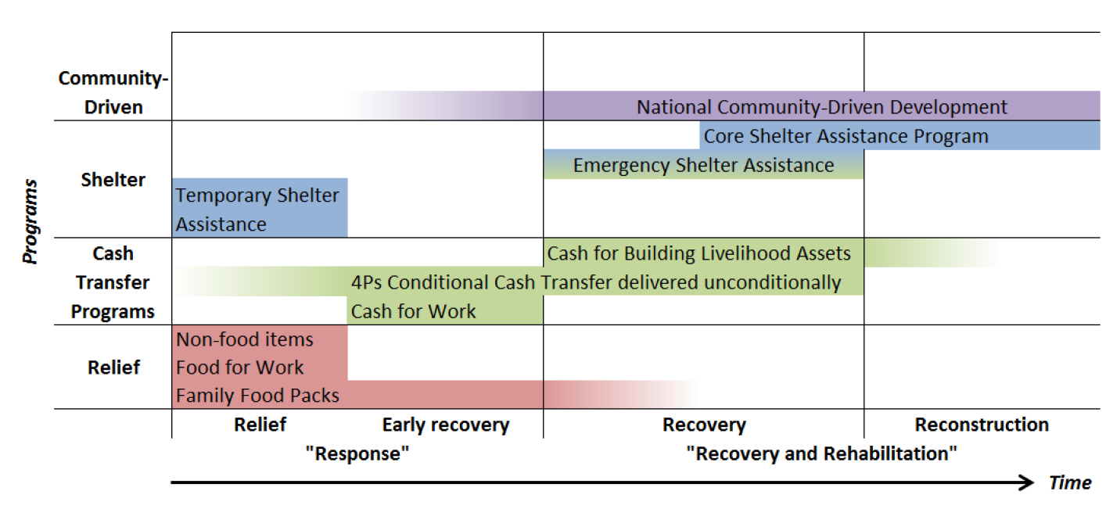
Source: Bowen, 2015
In instances where the use of an existing safety net program(s) is deemed to be appropriate, there are further nuances to be considered by program type. Each are explored below, including further considerations on the relative opportunities and limitations they present for disaster response and recovery. Moreover, as noted below, even where an existing safety net program does not exist, or does not meet these criteria, there may be options for creating a dedicated, ad hoc emergency program with these characteristics.

Types of Social Protection Programs

Cash transfer programs
Regular safety net program characteristics: safety net cash transfer programs include the provision of assistance in the form of cash and other near-cash transfers (e.g. food stamps, vouchers etc.) that can be used to transfer resources to the poor and near-poor/vulnerable. The main, direct objective of cash and near cash transfer programs is to increase poor and vulnerable households’ incomes. Conditionality can also be attached to a cash transfer. The program is then called a conditional cash transfer program (CCT), as opposed to an unconditional cash transfer (UCT). Typical conditionalities include that a transfer is received only if a child attends school or completes a specified number of health center visits during infancy, to promote and improve human development related outcomes.
Disaster responsive program characteristics: cash is increasingly being turned to in the humanitarian sector as a post-disaster modality due to several advantages versus the more prevalent method of in-kind post-disaster transfers. However, the appropriateness of cash in a post-disaster setting needs to be considered based on several factors, as below. Pre-existing, government-led safety net cash transfer programs, ‘responsive’ or otherwise, are increasingly being leveraged as conduits to deliver cash to affected households after disasters. As noted in Box 4, the humanitarian Grand Bargain has noted the importance of linking humanitarian cash transfers more closely to national, social protection cash transfer programs, wherever possible.
Opportunities
- Multiplier effects: cash has been shown to have positive multiplier effects on local markets and economies.
- Efficiency: there can be significant efficiency and value for money gains for those implementing the program, compared to the stock piling and provision of in-kind alternatives.
- Choice: recipients report that cash gives greater choice and control over how best to meet their own needs and a greater sense of dignity relative to in-kind support.
- Dignity: cash is often preferred by beneficiaries over food and in-kind alternatives due to the greater dignity associated with the receipt of cash – empowering beneficiaries to choose what they need.
Limitations
- Reliant on functioning markets: cash is ineffective if markets are not functioning, which they may not be for some time after a disaster, particularly in the event of a fast onset, destructive disaster.
- Inflation: where markets are functioning, there is often inflation for key goods needed for recovery – e.g. food items or housing materials.
- Corruption: cash can be more prone to abuse and corruption or diversion relative to in kind transfers which must be accounted for and mitigated.
- Security: cash can raise security concerns for distributers and beneficiaries at payment sites and during transportation that must also be adequately mitigated.
Box 4: The Humanitarian Grand Bargain - Using cash transfer and national social protection systems to respond to shocks

The Grand Bargain is an agreement between more than 30 of the biggest donors and aid providers, which aims to get more means into the hands of people in need. The Grand Bargain was first proposed by the former UN Secretary General’s High-Level Panel on Humanitarian Financing in its report “Too Important to Fail: addressing the humanitarian financing gap” as one of the solutions to address the humanitarian financing gap. The Grand Bargain commits donors and aid organizations to providing 25 per cent of global humanitarian funding to local and national responders by 2020, along with more un-earmarked money, and increased multi-year funding to ensure greater predictability and continuity in humanitarian response, among other commitments.

The Grand Bargain emphasizes the need to link cash payments with the provision of social protection: “Delivering cash should, where possible and appropriate, use, link or align with local and national mechanisms such as social protection systems” (Grand Bargain Document, 2016, p.6), and commits aid organizations and donors to “Increase social protection programmes and strengthen national and local systems and coping mechanisms in order to build resilience in fragile contexts” (Grand Bargain Document, 2016, p.14).

Food and in-kind transfer programs
Regular safety net program characteristics: in-kind and food-based programs provide additional resources to households when they need them most, typically in the form of food rations, supplementary and school feeding programs, or emergency food distributions. Food and in-kind transfers are still a dominant transfer modality in many countries, including India, Indonesia, Egypt and Sri Lanka. A recent wave of evaluations has shown that, on average, in-kind transfers are less cost effective at delivering resources to households than cash transfers (Gentilini 2016; Margolies and Hoddinott 2015; Alderman et al., 2017).
Disaster responsive program characteristics: in-kind transfers are the predominant transfer modality among the humanitarian community – for example 93 percent of interventions are non-cash based (ODI, 2015). In-kind post-disaster transfers serve several important functions, including:
Opportunities
- Meeting lifesaving needs: in-kind, food and shelter assistance represent potentially lifesaving interventions immediately after a disaster when beneficiaries may lack access to either for some time.
- Not reliant on markets: essential alternative to cash where markets are not functioning or are not accessible.
However, attention is increasingly being placed on cash transfers due to several disadvantages of in-kind programs.
Limitations
- Logistics: the provision of in-kind transfers requires complex and cumbersome procurement, supply chains and delivery mechanisms/transport, stock piling and storage of resources that may perish over time.
- Cost: relative to cash, the logistics necessary for in kind transfer programs tend to imply higher costs than cash delivery.
- Lack of choice: unlike cash, the recipient has had the choice of precise assistance made for them (type of food, type of materials for shelter, rebuilding etc., type of inputs for livelihood rehabilitation, etc.).

Public works programs
Regular safety net program characteristics: labor-intensive public works (LIPW) programs have two main objectives: first, to provide a source of income to poor workers, and second, to construct or rehabilitate public infrastructure. Providing temporary employment at low-wage rate mostly to unskilled manual workers on labor-intensive projects such as road construction and maintenance, irrigation infrastructure, reforestation, and soil conservation, and more.
Disaster responsive program characteristics: public works have been widely employed as crisis response tools, providing temporary employment and providing the means to rehabilitate community infrastructure – both high priorities after a disaster. Self-selecting beneficiaries may be remunerated for their labor with cash and / or food. Similarly, the humanitarian community widely employ Cash-for-Work (CfW) related interventions following disasters.
Opportunities

- Contribute to rehabilitation: can provide social benefits to the community as a whole, beyond just the immediate recipient, including from post disaster clean-up and rehabilitation centered public works projects.
- Dignity: provide income support to the beneficiary while potentially maintaining a workers’ dignity, working for a return, not receiving a hand out.
- Self-targeting: public works programs can be self-targeted depending on the objectives. A program presents the wage and project, and then people decide to opt-in or not of their own volition. As opposed to transfer programs that are typically targeted based on damages or another metric for post disaster ‘need’.
- Wider support: public works programs tend to be more popular with both the public and with politicians due to the completion of works as opposed to the provision of a ‘hand out’ without the completion of a service.
- Climate co-benefits: longer-term public works activities can be designed to generate climate co-benefits. For instance, sustainable land management practices (such as re-vegetation, use of multi-purpose trees, or physical structures such as terraces, bunds, pits, and small dams) can store carbon in soils and vegetation while also generating adaption benefits by reducing water runoff and bringing degraded land back into productive use, therefore leading to higher yields and stronger defense against flooding and drought.
Limitations

- Administrative burden: public works projects are administratively demanding. Projects must be well designed and implemented, materials must be selected and procured properly, and the work must be supervised to ensure that it is done correctly. Such projects need to be planned ahead of time (except in the case of clean-up activities following fast onset disasters).
- Lengthy processing: often a public works project cycle is lengthy from selection of type of public works project to implementation, which can mean the program is not agile enough to be quickly rolled out after a disaster, unless it has been explicitly prepared to do so.
- Work requirement/condition: the programs are inaccessible to those unable to provide labor, including the elderly and disabled, both of which are among the most vulnerable to disaster impacts. Often such programs are complemented by unconditional transfers to vulnerable groups and those that cannot participate in the labor requirement.

Making safety net programs disaster-responsive
The transition from a regular safety net program to a disaster responsive safety net program that can be used in disaster recovery can be achieved through investing in “scalability”. A scalable safety net is a pre-existing safety net program with objectives related to poverty reduction, human capital development etc., that is additionally capable of responding to a disaster in the following ways:
- Scaling up (alternately referred to as vertical expansion (O’Brien et al., 2018)): Providing more assistance (amount and / or duration of assistance) to households that are pre-enrolled in an existing safety net program.

- Scaling out (alternately referred to as horizontal expansion (O’Brien et al., 2018)): Capable of adjusting to post-disaster needs and reaching households not already enrolled in the existing safety net program but deemed eligible for post-disaster assistance due to the impacts of the disaster. Programs capable of scaling out are typically able to scale up also.

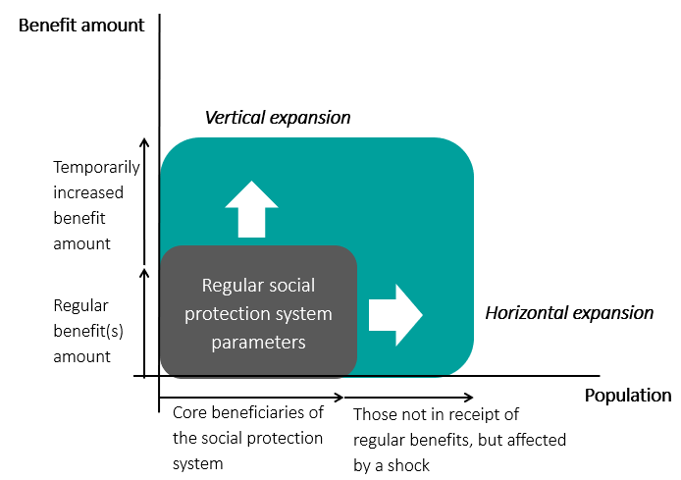
Figure 1: Scalability in an adaptive social protection program. Source: World Bank, 2016
- Dedicated emergency program (alternatively referred to as piggy backing (O’Brien et al., 2018)): Several countries do not formally ‘scale up or out’ an existing safety net program, instead creating or utilizing a dedicated emergency program with similar characteristics – cash, in kind, public works, which may leverage the same underlying safety net delivery systems as built and used by regular non-emergency safety net programs.

Scaling up an existing safety net program / Vertical expansion
Where a safety net exists and has a good degree of coverage within disaster affected areas, “scaling up” the program offers the path of least resistance and complexity. It is an increasingly common safety net led disaster response tool, predominantly used for cash transfer programs. In many places, scaling up has been a pragmatic method for ex-post disaster responses that have leveraged safety nets after a disaster has already occurred to deliver assistance to households. Well known global experiences include the Philippines and Fiji (see snapshots below, among others). Scaling up assistance in this manner can be an effective means to reach pre-identified and already registered poor and vulnerable households with assistance at an acute time of need through an existing delivery conduit. However, a serious constraint is an inability to reach other households that have been affected and who may be equally or more in need of the assistance as the pre-existing safety net beneficiaries. These other households will need to be reached through other programs delivered by different government MDAs or humanitarian partners.
Opportunities for scaling up an existing safety net program
- Simple: using existing systems and processes to simply deliver more assistance to an existing pool of beneficiaries that are already registered and enrolled.
- Minimal preparedness required: evidenced by the fact this is most often employed after a shock with no preparedness at all;
- Pro-poor: Reaches some of those most vulnerable to the impacts of disasters since the pre-existing safety net will target poor households.
- A first step: this can be a first step in a more ambitious engagement that later seeks to introduce greater complexity such as through ‘scaling out’ but that faces serious capacity and / or political constraints.
- Partners: actionable partnerships with development partners and humanitarian actors who may also choose to channel a share of their post disaster support through the safety net to contirbute ot vertical expansion through “top-ups” (see Philippines and Nepal cases below, for example).
- Timeliness: May be fast as the delivery channel to the program’s beneficiaries is already established.
- Cost-effectiveness: relatedly, may be cost effective relative to alternative interventions.

Limitations
- Limited responsiveness: delivering assistance in this way may not be reflective of needs on the ground. Among the affected, there may be those equally or more in need of assistance than existing beneficiaries but who were not in the regular social protection program. With this method those people can’t be reached.
- Inequitable: due to the above limited responsiveness, there may be issues of equity which can cause dissatisfaction and unrest. A response based on program limitations and not on actual needs is suboptimal, even when pragmatic.
- Finance: the feasibility, scale and timing of the response will be determined by the availability of financial resources to cover this increase in programs costs.
Snap shots of global experiences in scaling up, through vertical expansions and top-ups to existing beneficiaries:
Fiji vertical expansion through the social protection system– Tropical Cyclone Winston, 2015
Fiji was severely affected by tropical cyclone Winston in February 2016, which killed 44 people and caused damages and losses to the productive, social and infrastructure sectors of US$ 959 million (22% of the country’s GDP). In response to the cyclone, the Government of Fiji made additional transfers through its existing social protection system, in particular, the Poverty Benefit Scheme, Social Pension Scheme and Care and Protection Scheme. Transfers were equivalent to three months of regular transfers and were made to all existing beneficiaries, regardless of whether they were affected by the disaster or not. In addition, the Government of Fiji provided low income households whose homes were damaged or destroyed with vouchers for repairs and reconstruction under the Help for Homes initiative. An impact assessment of the response to TC Winston through the social protection system found that households that received assistance were more likely to report having recovered from various shocks; for instance, they were 8-10% more likely to have recovered from housing damage. For further details on the response to tropical cyclone Winston, see Mansur, Doyle and Ivaschenko 2017.

Philippines scale up through the Pantawid cash transfer program – Typhoon Yolanda, 2013
Typhoon Yolanda, which was one of the strongest typhoons ever recorded, struck the Philippines on November 8, 2013. The storm led to storm surges of over 4 meters in some regions, and nearly 6,300 people died, with a further 4.1 million displaced (Bowen, 2015). The Government of the Philippines responded to Typhoon Yolanda through its social protection systems, notably the Pantawid Pamilyang Pilipino Program (4Ps). The 4Ps is the Philippines flagship nationwide conditional cash transfer (CCT) program to reduce poverty and build human capital, with 4.4. million beneficiaries in 2014. The 4Ps program was used following Typhoon Yolanda to provide assistance to affected beneficiaries. Following the declaration of a “state of calamity”, program conditionalities were waived in specific geographic areas for a certain amount of time (Bowen, 2015). Between November 2013 and February 2014, a total of US$ 12.5 million were distributed. Top up cash and in-kind support was provided for 4Ps beneficiaries for an extra two months, covering 100% of the food basket (Oxford Policy Management, 2017).
Both WFP and UNICEF used the national household targeting system and 4Ps delivery system to provide assistance to affected households following Yolanda. WFP and UNICEF topped up the amounts provided by the Philippines Department of Social Welfare and Development (DSWD). In parallel, WFP provided assistance to those that were not beneficiaries of the 4Ps program through its INGO implementing partners. Replicating the response to typhoon Yolanda following typhoon Hagupit in 2014, WFP also provided assistance through the 4Ps program’s delivery systems.
Tonga, vertical expansion through elderly and disability programs - Typhoon Gita, 2018
Tropical cyclone Gita passed directly to the south of Nuku’alofa and severely impacted large parts of the main island, Tongatapu, and neighbouring ‘Eua. The following morning, before the cyclone had fully cleared, Tongans were out on the road clearing the debris from the night before. The response from the people and Government of Tonga was swift. The UN Humanitarian Cluster system was quickly activated, and the major donors provided rapid assistance. However, one element of the response was particularly noteworthy: the Government channeled nearly a million Tongan Pa’anga ($A500K) through their Social Welfare Scheme for the Elderly and Disability Benefits Scheme – the Government’s two core social protection programs. These are two vulnerable groups that weren’t in a position to rebuild the following morning. The cash was quick to be disbursed, given the programs are already operational, and provided funds for their immediate post-disaster needs. The financing was provided by the Australian Government, but drawing on the Government’s SP systems. (Government of Tonga, 2018).
Nepal, vertical expansions provided by UNICEF through the social protection system – Earthquake 2015
In 2015, Nepal was affected by a devastating earthquake, which killed more than 8,700 people, injured over 22,300 and caused damages and losses of over US$ 7 billion. The earthquake destroyed 490,000 houses and rendered an additional 265,000 houses temporarily uninhabitable. During the 2015 earthquake response, UNICEF used the social assistance system to deliver cash assistance to approximately 434,000 people in 19 districts of the country. An existing working relationship with the Government of Nepal helped with providing cash-based humanitarian assistance at scale within 2 months. A flat amount of 3,000 Nepalese Rupees was provided to each beneficiary as a top-up to the existing social assistance payment by the government. The amount transferred was equivalent to approximately 2 months of consumption for an individual at the poverty line. The program benefited from using the government delivery systems, which allowed for a relatively quick and cost-effective delivery of assistance (UNICEF, 2015).

Scaling out an existing safety net program / Horizontal expansion
Operationally more challenging, requiring significant investment and preparedness. The ability to scale out enables a safety net program to include new households into the program based on eligibility from a disaster’s impacts. Introducing the ability to scale out in this manner is far more complex operationally and will benefit from significant preparedness measures and investment to adapt underlying systems, processes and capacities to do so. Many countries are beginning to introduce this functionality as a key to building a responsive safety net, with prominent examples included below in the operational snapshots for Kenya, Ethiopia, Uganda and Mexico.
Opportunities:
- Flexible to meet post-disaster household needs: a program that can scale out can better meet changed needs on the ground than one which can’t.
- Leveraging existing systems: building on top of an existing delivery mechanism provides a strong foundation for this additional functionality.
Limitations:
- Benefits from significant investment, ex ante: horizontal expansion will be easiest when investments have been made in advance including with regard to program design features and their delivery processes, financial preparedness, information systems, institutional arrangements and partnerships (summarized in section 5).
This is not to say it will not be possible to implement horizontal expansions post shock, especially if government leadership and capacity is strong, however this will likely be at the expense of a timely response.
- Scaling down: once new beneficiaries have been incorporated into a safety net on a temporary post disaster basis, stopping benefits to them following the disaster – scaling back down – can be difficult.
Snapshots of global experiences in scaling out:
Kenya’s Hunger Safety Net Programme (HSNP)
A commonly quoted example of Horizontal Expansion is that of Kenya’s Hunger Safety Net Programme (HSNP). Under its second stage of implementation, the HSNP provided regular, unconditional electronic cash transfers (Kshs 5,100 every 2 months) to 100,000 households. The program was also designed to scale up and down (as well as scale out horizontally) in response to weather shocks (e.g. drought/ El Nino), to include an additional 272,000 households in the country and support with cash transfers. The poverty-targeted cash transfers were conducted electronically, with payments made directly into fully functioning bank accounts using biometric and pin-enabled bank cards via the banking agent network.

In 2015, a total of 4 separate scale-ups were completed (with DFID funding). The scale-up (and down) in response to drought is triggered by remotely sensed data (i.e. satellite data, a Vegetation Condition Index). When the VCI hits the “severe” or “extreme” threshold in any sub-county in a county, this generates a quota of households (HHs) to receive a scaled-up payment with the following categorization: sub-counties in severe drought = 50% of all HHs minus - routine beneficiary HHs; sub-counties in extreme drought = 75% of all HHs minus - routine beneficiary HHs. The scale-up covers pre-defined sets of households based on HSNP MIS wealth groups (thereby not using targeting during disasters but rather a pre-targeted group). Additionally, only HHs with active bank accounts could receive the scale up payment.
Ethiopia’s Productive Safety Net Program (PSNP)
The Productive Safety Net Program (PSNP) is a large, national SSN program, designed to respond to the impacts of chronic drought, food insecurity, and climate change on Ethiopia’s poorest households. To do so, the PSNP incorporates public works activities that improve climate resilience and promote community-level adaptation; provide a federal contingency budget to help poor households and communities better cope with transitory shocks when they occur; and target methods to identify those communities most vulnerable to shocks and climate change. These investments in more dynamic targeting for the PSNP and other preparedness measures enabled the program to extend the duration of its regular support for 6.5 million existing beneficiaries, providing an extra two-to-three month of assistance (vertical expansion), while also releasing contingency funds to enroll an additional 3.1 million beneficiaries who were not in the core PSNP caseload (horizontal expansion) in response to the droughts of 2011 (Slater and Bhuvanendra, 2013).
The scalability feature of the Productive Safety Net Program was designed to provide a first line of response to drought, complementing the existing humanitarian appeal mechanism, which will continue to be used to respond to needs in areas outside the Productive Safety Net Program districts or in cases where needs within the Productive Safety Net Program districts exceed available resources. During the 2011 Horn of Africa crisis, the administrative and logistical infrastructure of the Productive Safety Net Program proved capable of scaling up the coverage of the program very rapidly, thereby strengthening the capacity of hundreds of thousands of vulnerable households to withstand a series of unexpected shocks.
Uganda - The Northern Uganda Social Action Fund (NUSAF)
The Northern Uganda Social Action Fund (NUSAF) developed from a livelihood promotion (NUSAF I) into a public works program (NUSAF II). NUSAF III’s Disaster Risk Financing component allows for the prompt response to disaster events, whilst also building capacity to store and analyse data to identify when a disaster response through the safety net would be needed (World Bank, 2015).
In response to the 2016 El Niño-induced drought, Uganda’s Third Northern Uganda Social Action Fund (NUSAF III) project scaled out. The NUSAF III project is a public works project that includes a contingency component to finance drought risks, when a parametric trigger event is met (specifically, scalability of NUSAF is linked to the Normalized Difference Vegetation Index, NDVI). In response to the drought in 2016, the NUSAF III public works program was scaled out in August 2016 to include an additional 30,000 households (approximately 150,000 people). Assistance was provided through a drawdown on US$ 4 million from a US$ 10 million contingency fund (World Bank, 2017). While the response was successful, there were some delays in payments, as payment mechanisms at district level were only just being put in place.
Mexico
Following the food, fuel and financial crisis, Mexico’s Oportunidades program, together with the Food Aid Program Programa de Apoyo Alimentario scaled out to reach 1.35 million new poor families (FAO, 2017). Moreover, a new cash bonus to assist children aged 0 to 9 was added (Ibid.). Oportunidades monthly payments to the poorest families increased by 24% (Oxford Policy Management, 2017, Bastagli, 2014).

Mexico’s Programa de Empleo Temporal (PET) has scaled up in response to economic shocks and natural disasters. Mexico’s PET is a temporary employment program overseen by the Ministry of Social Welfare (SEDESOL) and implemented by several sectoral ministries. In 2003, an emergency response and contingency financing mechanism was added as a subcomponent of PET in 2003, the Programa de Empleo Temporal Inmediato (PETi). The PETi operates within PET but has modified systems and procedures for a post-disaster context. At least 20 percent of the PET program budget is reserved for responding to emergency situations of low to medium impact. For more severe disasters, all funds in SEDESOL’s annual budget for PET can be used towards addressing the needs of those affected by disasters through PETi. Further, if these resources are insufficient, further funding for PETi can be obtained from FONDEN, Mexico’s natural disaster fund (World Bank, 2013).

Emergency programs and “piggy backing”
Several countries do not formally scale up or out an existing safety net program, instead using a dedicated emergency program with similar characteristics, which may leverage safety net sub-systems in its delivery (“piggy backing”). Often, emergency programs are created in response to a disaster, and may be formalized and embedded over time, or they may be used only once. These emergency programs may be located within or outside of the social protection Ministries, Departments and Agencies (MDAs), often in Departments of Agriculture or Departments for Food Security, to name a couple. These emergency programs are separate to an existing safety net program, holding dedicated response objectives – i.e. they do not require “scalability”, but they will possess similar characteristics to safety net cash transfer, in-kind or public works programs. The emergency program may leverage the same underlying safety net delivery systems as built and used by regular non-emergency safety net programs – information systems such as social registries, payment systems, front line social protection staff, etc. This process has been referred to as “piggybacking” by O’Brien et al., 2018.
Opportunities:
- Dedicated and clear objective: not constrained by parameters of an existing safety net program, the primary objective is to meet disaster needs, implying in-built flexibility for this purpose, by design.
- Ring fences existing safety net programs: by not bringing disaster affected households into a safety net program on a temporary basis, the above-mentioned issues of scaling down after a disaster can be avoided.
Limitations:
- Benefits from significant investment, ex ante: as with scaling out, the complexity benefits from significant investment and preparedness to be undertaken, ex ante. However, the case of Pakistan below highlights that such programs can be created after a disaster where strong government leadership and capacity are found – though likely at the expense of the timeliness of the response.
- Program fragmentation: the introduction of an additional standalone program can create greater fragmentation in a social protection portfolio that must be managed accordingly.
- Institutional fragmentation: relatedly, such emergency programs, utilizing social protection may not be housed within the traditional counterpart for social protection which can cause overlapping mandates and a lack of clarity on roles and responsibilities.
Pakistan’s Citizen’s Damage Compensation Program (CDCP)
In July and August 2010, during the monsoon season, Pakistan experienced the worst floods in its history (World Bank, 2010). To respond to the floods, the Government put in place a temporary nationwide social safety net (SSN) program - the Citizen’s Damage Compensation Program (CDCP) - that successfully reached an estimated eight million flood-affected people through cash transfers. During Phase 1 (which ran from September 2010 to June 2011), the goal was to provide quick assistance to families (one off cash transfers of PRK 20,000, or approximately US$ 213) who lost their homes or faced a serious threat to their wellbeing because of the flood (using geographical targeting). Phase II of the CDCP started in 2011 with the goal to support the recovery of affected households. Flood-affected households, including many of those from Phase I, were provided with cash payments which could be used to meet any of their recovery needs, such as reconstructing their houses, restoring their livelihoods or paying back accumulated debt. With additional donor support available, the Government of Pakistan (GOP) was able to double the size of the grant to eligible households to PRK 40,000 (around US$ 426), a more suitable amount to support recovery. The program also led to the development of a SSN disaster preparedness action plan by the GOP for future disasters and crises.
This specific response mechanism used by the Government of Pakistan benefitted greatly from the National Database Registration Authority (NADRA) which maintains a database of civil registration data of over 96 million citizens in Pakistan and abroad, and from a database of the beneficiaries of an ongoing national SSN program. The CDCP made use of both of these databases to identify its beneficiary household pool. NADRA also helped CDCP refine its eligibility criteria by triangulating household data with other disaster specific eligibility criteria to verify beneficiary eligibility and produced lists of over 2 million beneficiaries.
East Asia emergency programs
Many countries in the East Asia region possess ad hoc, on demand, post-disaster assistance programs. Where SSN systems are less developed than in countries like the Philippines and Fiji, or where a larger disaster responsive safety net response has not been considered, emergency assistance programs often exist and function on an application or assessment based, case by case basis. This review has found examples of such programs in Malaysia, Vietnam, Cambodia, Indonesia and Laos. In each case, they appear to be small in scale and application or assessment based – divorced from larger SSN delivery and information systems. In Malaysia, for example, a disaster relief program exists, and was availed by 6,440, 14,230, 9,820 households in 2008, 09, and 10 respectively (latest data available, ADB 2012). In Lao, the Ministry of Labor and Social Welfare seemingly manage a Disaster Relief and Assistance program that accounted for 4.4 percent of total social protection expenditure in 2009 for categories listed as “flood victims” and “food security”. In Vietnam, the Emergency Assistance Program is larger in scale and is the main social assistance response to disasters. A recent World Bank paper (2016) found that, in 2010, the program assisted about 491,000 households (1.9 million individuals) with cash benefits estimated at VND 1.8 billion (USD 84.2 million) in cash and VND 0.4 – VND 0.6 billion (USD 0.2 million – USD 0.3 million) for rice.
Mauritania: Lean season response through the Elmaouna emergency program
Since 2017, Mauritania is implementing a shock-responsive safety net program, Elmaouna. Elmaouna, implemented by the Food Security Office, is targeting the most vulnerable households during the lean season and is based on ASP principles. Elmaouna was first piloted during the lean season in 2017. The program is based on a piggybacking scheme, using the Social Registry as well as the Tekavoul Payment Platform. It provided cash transfers to 1.000 households during the lean season in 2017 and to 3,500 households during the lean season in June to September 2018 . A transfer amount of MRO 2,400 per household was provided for four months (June to September) in 2018. The program provided the government with the opportunity to apply ASP principles. The successful implementation of this program (demonstrating cost-effectiveness and timely delivery) is feeding the systemic level and the policy dialogue on ASP.

The Elmaouna program provided to the government the opportunity to strengthen the dialog with the humanitarian community. Meetings were held with humanitarian agencies in order to coordinate interventions (geographical areas) and modalities (amount, timeline…) and to apply concretely ASP principles (use of the Social Registry for example).

Nepal’s emergency cash transfer after the earthquake of 2015
The government of Nepal supported affected households in three phases. During the first phase, around one month after the earthquake, the government distributed initial unconditional cash transfer based on the damage and loss. NPR 30,000 (about $300) as a funeral cost for those who lost a household member, NPR 15,000 (about $150) for those with fully damaged housings, and NPR 3,000 (about $30) for those with partially damaged housings. Before winter started, around half a year after the earthquake, those with fully damaged housings received an additional NPR 10,000 (about $100) as winter relief. About one year after the disaster, the government developed an emergency CCT, the Nepal Rural Housing Reconstruction Program (RHRP), to assist affected households with rebuilding their damaged homes. This program provides NPR 300,000 (about US$3,000) for housing reconstruction with three tranches based on completion of stages of construction milestones (eligibility verification, completion of a foundation, and completion of a roof) to encourage owner-driven reconstruction aligned with the Nepal National Building Code’s (NBC) earthquake-safer construction guidelines. The result of an inspection at each milestone is uploaded in the central system, and grants are to be transferred to beneficiaries’ bank account. As of March 2017, 540,856 beneficiaries (approximately 96% of enrolled beneficiaries) have received the first tranche of the housing subsidy.

Sources: The Asia Foundation, 2016; Willits-King and Bryant, 2016; Nepal Earthquake Housing Reconstruction Multi-Donor Trust Fund

Implementation considerations along the social protection “delivery chain”
The core steps for the delivery of social protection programs as part of a disaster recovery can be considered along the social protection “delivery chain”. While social protection programs pursue different objectives, most follow a common delivery chain, which addresses the key decision points for program implementation. Figure 2 below shows the social protection delivery chain. It is grouped into four phases (Assess; Enroll; Provide; and Monitor & Manage) and within these, into nine sequential steps. While the delivery chain summarizes key steps in the process to deliver regular social protection programs, similar steps are required for delivering social protection in a post-disaster context. This section provides a short summary of those steps including post disaster modifications – and is intended to provide initial considerations rather than a front to end implementation guide.
In each case, investments along the delivery chain made ex ante can expedite the process of delivering the program more efficiently and effectively post disaster.
Figure 2: The Social Protection Delivery Chain.
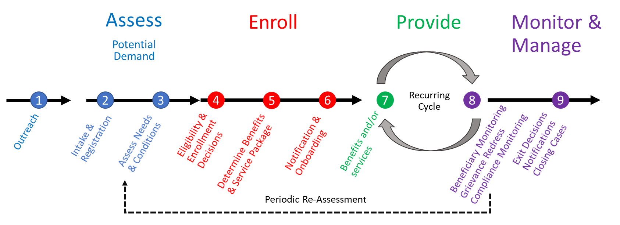
Source: Lindert, et al, Sourcebook (forthcoming)
- Outreach: How will I let affected households know that they may be eligible for support?
The objective of the Outreach process is to inform beneficiaries of the social protection program, create awareness, and encourage potential beneficiaries to apply. Outreach activities usually use a variety of communication mechanisms, including public messaging through the media (electronic and print); local information sessions through community structures; word of mouth; visual information campaigns; staff outreach; and digital communications (e.g. social media). Outreach activities are necessary to encourage potential beneficiaries to apply, and to inform existing beneficiaries on regular interactions, such as payment dates and times (Smith, 2018).
Post disaster considerations: Disasters can disrupt communication channels, undermining outreach activities. Therefore, the communication mechanisms may need to change in a post-disaster setting. For instance, where digital communication is interrupted, outreach may need to focus on word-of-mouth or staff outreach campaigns. Also, the type of information to be provided following a disaster depends on the type of response to be implemented. In the case of vertical expansions, beneficiaries will already be aware of the program, but may not be aware of the additional payment(s) to be provided. In the case of a horizontal expansion or piggybacking, the information provided would need to be more comprehensive, informing potential beneficiaries on the objective of the program, who can apply, how to apply, what kind of assistance they may expect and when, etc. (Smith, 2018).
- Intake & Registration: How should I gather information on the disaster affected households to assess their needs and potential eligibility for support?
The objective of the Intake & Registration process is to collect information on potential beneficiaries (individuals, households or communities), to be able to assess their eligibility for the social protection program. Intake and registration is completed either on demand, where potential beneficiaries register themselves (typically at social welfare offices), or en masse, in which case survey teams visit the population to collect household data. En masse surveying may have been used to establish a social registry containing information on social protection and non-social protection beneficiary households. Where a social registry exists, it may not be necessary to complete separate intake and registration processes for each social protection program, but rather the social registryserves as the basis for intake and registration for multiple programs (Smith, 2018), as depicted in Figure X. Some Social Registries have near universal coverage (Chile, Pakistan, the Philippines, the Dominican Republic, Colombia). Others cover between one third and one half of the population (Brazil, Georgia, Indonesia, Mexico, Montenegro, and Turkey). Others operate on a much smaller scale, either because they have been implemented in specific geographic areas before expanding to national coverage (e.g., China (rural areas RPHR), Djibouti, Mali, Senegal, Yemen) or because the programs they serve are very narrowly targeted (e.g., Azerbaijan) (Leite et al, 2017).

Figure: Intake and Registration through the social registry
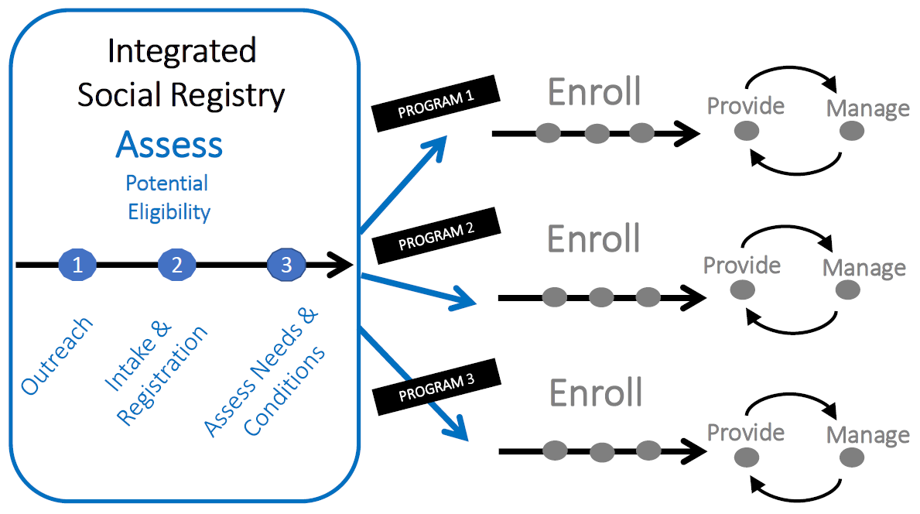
Source: World Bank, Lindert et al (Forthcoming); Leite et al, 2017
Post disaster considerations. In the case of a vertical expansion of an existing program, the registration of beneficiaries is already completed via the regular program. However, depending on program objectives, it may be necessary to leverage additional information, in the event that only some of the existing beneficiaries are to be targeted - e.g. only those that live in a disaster-affected area, prioritizing categorical vulnerabilities such as disability, old age, children, etc. For horizontal expansion or piggy backing, it will depend on the extent of the existing information contained in a social registry, as well as how up to date that information is. Where up to date and complete, the social registry will already contain the information on most of the households in the affected areas. Where otherwise, and even in those cases, additional information may need to be gathered through post disaster surveys or on-demand registration. Depending on the impacts of the disaster, it may be necessary to change the location and number of registration offices, including through temporary offices to facilitate such on-demand registration.
- Assess Needs and Conditions: Among the affected, who are most likely to require support?
The objective of this step is to assess needs of applicants according to eligibility criteria and screening tools, to determine whether they are eligibility for benefits, and to inform the determination of the benefits and service package. The assessment of needs and conditions is based on adherence to criteria-based information such as income / consumption and poverty status, age, gender or other categorical criteria, or geography. These are often relatively static and evolve infrequently.
Post disaster considerations. In case of vertical expansions, the eligibility criteria for regular programs are retained in the event of disaster, which can lead to exclusion errors as beneficiaries or households who are in need of assistance may not be among the regular beneficiaries of the program. By contrast, horizontal expansions or piggybacking allow for changes in the eligibility criteria of the program (using damage to the household as a proxy for eligibility, for example) and the reduction of exclusion errors
- Eligibility & Enrollment Decisions: Based on intake, registration and assessment, who should be enrolled into the program?
As part of the Eligibility & Enrollment Decisions process, program implementers decide which of the potential beneficiaries who completed intake and registration are included in the program as beneficiaries. Both applicants who are included in the program as beneficiaries, and applicants who are not included in the program, are informed of the decision. For beneficiaries, the enrolment process then includes the collection of additional documents (if applicable), as well as registration for the programs in which they are being enrolled, and preparation of the delivery of benefits and services packages, for instance, through establishing a payment mechanism / setting up a bank account. Beneficiaries are then provided with a beneficiary ID, or other means to verify their status as a beneficiary.
Post disaster considerations. In cases where disasters are disruptive, beneficiaries may lose their means of identification and documentation. Depending on the type of identification required, processes may need to be adapted. For instance, where identification is based on beneficiary IDs, these may need to be reissued following a disaster by program staff. Where identification is based on national IDs, the process to replace these documents is outside the jurisdiction of social protection program institution, such that assistance from the issuing authority would be required. In post-disaster contexts, biometric data is typically most easily verifiable. For the case of horizontal expansion, processes need to be adapted to enable the enrollment of new beneficiaries. Processes for eligibility and enrollment may need to be adapted to enable the rapid inclusion of additional beneficiaries.
- Determine Benefits & Service Package: Once enrolled, what kind of benefits will they receive?
As part of the Determination of the Benefits and Service Package, the beneficiary list is finalized prior to each payment, the amount of the transfer is set and provision points are determined. The determination of benefits and services packages will seek to ensure that the benefits and services provided are appropriate in light of need, and will depend on resource availability and political feasibility. For regular social protection programs, benefits and service packages are often determined so as to smooth consumption, reduce chronic poverty, provide assistance in the event of unemployment, or ensure an adequate pension.
Post disaster considerations. Typically, benefits and service packages are designed to address chronic, rather than transitory, needs. Therefore, benefits and service packages may need to be modified to address the needs generated in post-disaster situations. For instance, where benefits are provided in cash, it is important to ensure that the amount provided is enough to purchase an appropriate amount of food for the household, and where benefits are provided in kind, the amount should suffice to meet nutritional requirements.
- Notification & Onboarding: how best to let the selected beneficiaries know they will receive support?
As part of the Notification and Onboarding step, beneficiaries receive notification that they have been selected as a beneficiary. Beneficiaries are informed of the benefits and service package they will receive, the timing and duration of payments and services, and the steps required to avail themselves of benefits and services.
Post disaster: As a result of a destructive disaster, it may be difficult to notify beneficiaries of their selection as beneficiaries of the program. This may particularly be the case where beneficiaries have been displaced as a result of the shock. As with the outreach stage, alternative mechanisms will need to be created to inform beneficiaries of the decision. Ideally notification could be delivered when the beneficiary applies for entry into the program, where possible.
- Benefits and/or services: how will I physically deliver this assistance to the selected beneficiaries?
The Benefits and/or Services process focuses on the provision of payments to beneficiaries. This requires providing the correct payment amount to the right people with the right frequency and at the right time (Grosh, del Ninno, Tesliuc, and Ouerghi, 2008). Payment modalities include physical cash, transfers to bank accounts, and mobile money. For electronic transfers, such as bank transfers or mobile money, this involves two steps: the provision of funds to the bank account / mobile money account, and the collection of funds by the beneficiary.
Post disaster considerations. In the event of destructive disasters, payment processes can be disrupted. For instance, pay points and offices of Banks or payment services providers can be destroyed or rendered inaccessible and a lack of connectivity can affect mobile money and ATM networks. Therefore, in the event of disasters, it can be useful to temporarily switch to manual payment provision. Moreover, temporary pay points can be set up to ensure accessibility. In the cases of both vertical and horizontal scale-ups following disasters, additional transactions will increase the work load of staff, the payment service provider and additional financial resources at the local level will be required for distribution.
- Beneficiary Monitoring, Grievance Redress and Compliance Monitoring: Is the program functioning effectively, responding to needs, and do I need to make any adjustments?
The objective of this step is to ensure that grievances made by beneficiaries and non-beneficiaries are addressed, as well as to conduct beneficiary monitoring. This includes, for instance, monitoring payment receipt, ensuring that beneficiaries meet conditionalities, such as health and education conditions, recording grievances and complaints, addressing administrative issues related to delivery, and facilitating case management processes. To ensure that these processes are implemented effectively, it is important that the processes are supported by adequate human resources, and that systems are in place to record these processes.
Post disaster considerations: Following a destructive disaster, damaged offices, a breakdown of communication channels and limited staff (who themselves may be among the affected) can create challenges in maintaining program operations. Further, post-disaster contexts may be associated with additional demands on the system. Additional complexities include changed program conditionalities, the inclusion of new beneficiaries and introduction of temporary modifications. These challenges can be addressed by temporarily deploying staff from other regions, ensuring the availability of alternative data management options, and backing up systems (e.g. through the use of clouds). Where program conditionalities are in place, these can be waived temporarily; however, in such cases, this must be communicated clearly to program staff, beneficiaries and partners.
- Exit Decisions, Notifications, Closing Cases: When should the program be wound down and how will I inform the beneficiaries?
As part of the Exit Decisions, Notifications and Case Outcomes process, it is assessed whether beneficiaries have met the conditions to graduate from the program and are notified that they will exit. Where there are changes in regulations and exit conditions, these would need to be communicated to beneficiaries. After beneficiaries exit the program, cases are closed.
Post disaster. Programs that were scaled up need to be scaled down after the emergency. Scaling programs down following an emergency can be difficult. Different approaches include scaling down the program after a certain amount of time / certain number of transactions or following a change in household vulnerability indicators after the assistance was provided, for example. While scaling down following a vertical expansion requires a termination of additional payments, scaling down following a horizontal expansion can be more challenging as it involves reducing the caseload. In some cases, however, beneficiaries who have been newly included in the program as part of the horizontal expansion may qualify for continued assistance; where this is the case, these decisions need to be communicated carefully to ensure there is clarity on which beneficiaries will continue to receive benefits and which will exit the program. In each case, social protection case workers should connect beneficiaries to additional, longer term (non-disaster specific) social protection programs for which they may be eligible.

A typology for assessing readiness and establishing policy priorities

Ultimately, the extent to which social protection can be used in these ways following a disaster will depend to a large extent on the strength of the social protection system in a given country - its comprehensiveness and its responsiveness. A typology can be developed incorporating these two key dimensions: (i) the comprehensiveness and maturity of the social protection system: its policies, programs and administrative sub-systems; (ii) the capacity of the social protection system and its constituent programs to respond to shocks.
Figure 3: Typology for country readiness and priorities
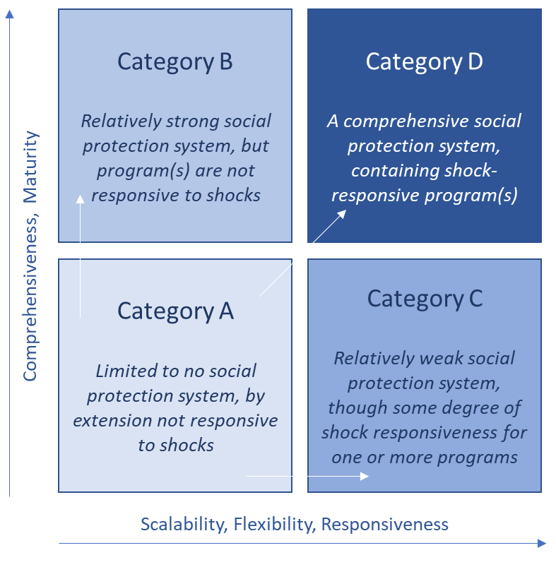
Along these two dimensions, four broad categories of countries can be distinguished (see Figure 3). Depending on the category a country is in, different options are available to use social protection system for disaster response and recovery. At the same time, depending on the category of the country, there are different priorities countries could look to address to better enable their social protection system to respond to shocks in the future.
Category A Countries: Limited to no social protection system, by extension not responsive to shocks.
- Common traits for Category A countries social protection systems:
  - The Social protection system is very limited, containing many small scale, fragmented programs;
  - The social protection systems and its programs can’t respond to shocks in any deliberate way;
  - There are significant gaps in the coverage of households;
  - There is no comprehensive Management Information System, may be paper based or utilizing basic database management tools;
  - Beneficiary identification is hampered by a lack of national ID cards;
  - Social Registries are non-existent or contain only information on existing beneficiaries of the small programs;
  - There is limited institutional capacity (physical, human, financial) for the implementation of social protection;
  - The policy framework for social protection is weak or non-existent.

- Advice for steps to implement immediately after the disaster: The direct role for social protection in the response and recovery will be limited. The emphasis for such countries is on what can be done next time, with the disaster itself being used to advocate for developing a basic social protection system. Priorities include assessing the potential contribution for a stronger and more responsive social protection system to the response and recovery. This assessment may be strengthened by: collecting data on who was affected and how severe the impacts were; what assistance those households received and how effective it was in mitigating impacts on their wellbeing; what worked well in the response and what needs further improvement, especially in terms of institutional coordination and gaps in assistance to affected households?

- Advice for steps to implement ahead of the next disaster: The disaster itself may be used to advocate for developing a basic social protection system including for future scalability and emergency programming. There is also an opportunity to move more directly and purposefully toward responsiveness and Category D, leapfrogging the kinds of rigidity found in Category B countries.

Figure 4: Social Safety Net coverage, latest year, and risk of natural disasters (low to high/left to right)

Source: Author using ASPIRE

Category B Countries: Relatively strong social protection system, but program(s) are not responsive to shocks.
- Common traits for Category B countries social protection systems:
  - There may be a large national safety net program such as a national cash transfer or public works program;
  - There a social registry containing information on social protection beneficiaries and non-beneficiaries will often exist;
  - There is strong institutional capacity (physical, human and financial) for the implementation of social protection;
  - There is a strong policy framework for social protection;
  - However, there has been limited / no experience with responding to disasters through safety nets.

- Advice for steps to implement immediately after the disaster: Vertical expansions and payment top-ups may be feasible, and desirable where the program beneficiaries are strongly correlated with the disaster affected. Vertical expansion may be delivered through the existing program, as in the case of Fiji and the Philippines. With the addition of understanding how well the vertical expansion worked and how accurate (or not) targeting was, how adequate benefit levels, whether the payment arrived in time, whether the coordination between SP + the humanitarians worked well, whether benefit levels were coherent, possible inclusion / exclusion errors, etc.

- Advice for steps to implement ahead of the next disaster: Formalize the process for vertical expansion ahead of the next disaster – including with dedicated, prepositioned resources, standard operating procedures and triggers for its use, and formalized arrangement with partners that may also use the program to channel a share of their assistance in the future. Also, use the experience of topping up / vertical expansion to advocate for the development of increased scalability (horizontal expansion) or the development of a dedicated emergency program to be better able to meet household needs for the next disaster.
Category C Countries: Relatively weak social protection system, though some degree of shock responsiveness for one or more programs.
- Common traits for Category C countries social protection systems:

  - As in Category A, the Social protection system is very limited, containing no programs or many small scale, fragmented programs;
  - There are large gaps in household coverage;
  - There is no comprehensive Management Information System, and program management may be paper based or utilizing basic database management programs;
  - Beneficiary identification is hampered by a lack of national ID cards;
  - Social Registries are non-existent or contain only information on existing beneficiaries of the small programs;
  - There is limited institutional capacity for social protection;
  - The policy framework for social protection is weak or non-existent.
  - However – some capability for shock response has been developed, most likely through a dedicated emergency program.

- Advice for steps to implement immediately after the disaster: While the underlying SP system is itself relatively weak, i.e. with fragmented programs, weak policy and institutional environment or rudimentary information systems, the country has developed responsive capability through scalability, or more often, through a dedicated emergency program. The responsive program can be leveraged to deliver assistance. During the recovery, assess the effectiveness of the program within the wider response and recovery effort, whether there was good coordination with other interventions, and the extent to which it was able to meet household needs in a timely fashion.

- Advice for steps to implement ahead of the next disaster: Where the responsive program is small scale, there will be a need to focus on investing in that program being better able to meet household needs ahead of the next disaster. Concurrently, this will benefit from continued investment in the wider social protection system – it’s policies, programs and sub-systems – so that they can provide a stronger platform for the emergency program’s delivery, or the development of additional emergency programs an scalability, as required.

Category D Countries: A comprehensive social protection system, containing shock-responsive program(s).
- Common traits for Category D countries social protection systems:
  - The country has a significant social protection sector (e.g. a national safety net, safety net system or safety nets that are in the process of being consolidated);
  - The safety net has been used to respond to shocks previously;
  - The safety net has an adequate targeting system for chronic and transitory needs;
  - Disaster contingency plans are in place;
  - Sustainable financing for responding to shock through safety nets has been arranged;
  - There is an (advanced) Management Information System;
  - There is a beneficiary registry;
  - There is a reliable and rapid payment mechanism;
  - Scale-ups are informed by early warning data, based on a pre-determined trigger;
  - There is strong institutional capacity for social protection and disaster risk management;
  - There is good coordination among social protetion and disaster risk management institutions;
  - Accurate monitoring and evaluation data is available.

- Advice for steps to implement immediately after the disaster: The ideal scenario, including a well-prepared program(s), designed to meet household needs generated by a disaster through scalability. The program(s) will be a central pillar for the overall government led response and recovery. The emphasis during this recovery should be placed on continued learning and improvement ahead of the next disaster in terms of the program’s timeliness in response, its effectiveness at meeting household needs, it’s coordination with other interventions and its cost effectiveness.

- Advice for steps to implement ahead of the next disaster: Continued investment in strengthening the program through monitoring and evaluation during the last disaster for iterative learning and continued improvement.
A rough typology - no substitute for a detailed analysis. While this typology and categorization may provide an indicative, quick assessment of what can and can’t be done after a disaster and the priorities ahead of the next disaster, more rigorous assessments conducted ahead of a disaster will of course yield more precise recommendations. A rigorous stock taking of the disaster risks faced by households – their exposure and vulnerability, alongside an extensive stock taking of the post disaster assistance available to those households (from outside of the social protection system), alongside stock taking of the social protection system’s coverage and responsiveness will help to reveal the primary gaps in meeting household needs that may be filled by introducing scalability to existing safety net program(s) and creating an additional dedicated emergency program(s). Going a step further, these kinds of analyses can be leveraged to conduct a fire drill exercise with stakeholders (Box 5).

Box 5: “Fire drill”

A fire-drill is a scenario-based workshop for policy makers and implementers to assess bottle necks in the provision of social protection to disaster affected households after a disaster has hit. This format brings stakeholders together from relevant Ministries, Departments and Agencies (and external actors) to simulate what would be the outcomes of a disaster scenario on households, and the ways in which they may be constrained in meeting household needs, with a focus on social protection. The workshop is based on pre-prepared analysis of the kind mentioned above.

The primary output from a fire drill such as this would be:
- The outlines of a contingency / response plan detailing the roles of social protection in disaster response and recovery;
- A roadmap prioritizing investment and system building to improve responsiveness of social protection;
- The basis for further collaboration and momentum around building this capability across relevant government departments.

Adaptive Social Protection: Preparing to respond to the next disaster
The adaptive social protection agenda focuses on preparing countries to be more-ready for the next disaster, through investments made in several core building blocks. While this note focuses primarily on options for utilizing social protection for disaster recovery; after the disaster occurs, the Adaptive Social Protection agenda recognizes the constraints in using social protection in recovery and is primarily a preparedness agenda focused on the ways in which certain investments can improve its effectiveness in recovery.
Adaptive Social Protection highlights five core building blocks for investment to improve responsiveness: (1) government leadership; (2) institutional arrangements; (3) data and information; (4) programs and their delivery systems; and (5) finance. The building blocks are depicted in Figure 5. Building a comprehensive ASP system will require investing in ASP across these five building blocks, as detailed below. The roadmap can present pathways on moving toward becoming a Category D country with a comprehensive social protection system that is responsive to shocks.
Figure 5: The building blocks of adaptive social protection.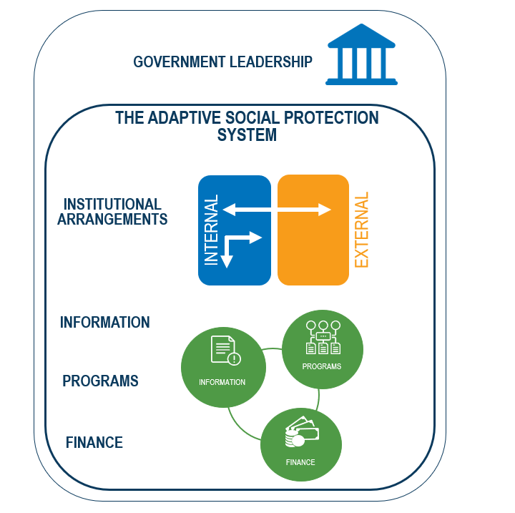
.
- Government leadership
Government leadership and ownership of the ASP agenda is a pre-requisite to the development of ASP, internalizing the responsibility to manage the risks from disasters as well as the responsibility to assist vulnerable households, and ultimately to develop adaptive social protection. While hard to quantify or measure, leadership can be evidenced by: 1) the identification of such priorities and objectives in high level and sectoral strategies, plans and policies; 2) through the presence of appropriate financial commitments to the sustainable development of adaptive social protection; and 3) through government’s monitoring of and reporting on service delivery in response to shocks, thus demonstrating its accountability.
- Institutional arrangements
Adaptive social protection involves myriad actors, many of which may not be traditional partners with the SP sector. This includes, most prominently, the DRM related coordinating and implementation bodies that in many instances do not understand the potential value added of social protection for disaster response and recovery. As such, the development of ASP requires a high degree of coordination among relevant MDAs around shared objectives. Similarly, at an implementation level, ASP requires investment in additional capacity – including human capacity - at all levels of government in order to be able to deliver a shock response effectively, and especially among social protection MDAs for whom shock response is a significant departure from business as usual operations and capacity. Existing institutions and institutional arrangements may be able to advance the ASP agenda, or ASP may require the formation of new institutions or institutional reform. In most contexts, the development of strong partnerships with non-government actors including the humanitarian community will be critical for ensuring post-disaster coordination around ASP related interventions and the design and delivery or responsive programs.
- Data, analysis and information systems
New information and analyses are required to better understand risk and vulnerability as a basis for program design and implementation: who is affected by shocks, how frequently, where, who among them is most in need of assistance, how much assistance is required, etc. For instance, by overlaying poverty maps with hazard maps, one can identify the areas which are most affected by poverty and vulnerability to disasters. Moreover, based on early warning data, early responses to shocks through social protection programs can be triggered. Therefore, specifically, ASP requires integrating DRM data analyses and information systems with social protection data, analyses and information systems. This can be done by creating common databases accessible by multiple stakeholders, including prominently through the use and adaptation of Social Registries. Relatedly, a stronger evidence base on the effectiveness of ASP related interventions is required to continue to guide future implementation.
- Programs and their delivery processes
Based on an understanding of risk and vulnerability, safety net programs designed and prepared to be able to meet household needs. Essentially, based on a greater understanding of risk and vulnerability and the gaps in terms of anticipated household need following disaster, programs with parameters to meet those needs and fill those gaps are designed in the ways described in section 3. Moreover, their delivery processes are prepared to enable them to be responsive.
- Finance
To enable a timely response following a disaster, finance must be disbursed quickly through responsive programs to be delivered in a timely manner to beneficiaries. This can be achieved through pre-planning and pre-positioning of resources that are linked to responsive programs. Two types of disaster risk financing and insurance instruments can be used to meet disaster-related needs: (i) ex ante instruments must be arranged in advance, before disasters strike; and (ii) ex post instruments are available to government following the occurrence of a disaster. Thereby, disaster risk financing instruments differ in the amount they make available, the speed of access and the cost of accessing finance. By combining different instruments, countries can protect against disasters of different frequency and severity (World Bank Group, 2014).
For more granular detail on key considerations by each building block, please consult the forthcoming World Bank Social Protection and Jobs publication funded by GFDRR; Adaptive: Social Protection and Shocks

Annex: Glossary

Term | Explanation
Active labor market program | Programs aimed at increasing the skills, employment, and long-run earning potential of participants through training, apprenticeships, job search assistance, subsidized job placements, and the like (Source: World Bank, 2011).
Adaptive Social Protection | Adaptive Social Protection systems, policies, and programs help individuals or households to better manage the risk of shocks – through an enhanced focus on instruments that build household resilience before shocks occur and after they have occurred.  First, ASP looks to build resilience before a shock occurs through promoting increases in household wellbeing that can conceivably move particularly vulnerable households above a wellbeing threshold. This results in a greater capacity to resist the negative impacts of future shocks when they do occur.  Secondly, ASP works in the post shock phase to hasten recovery among affected households –ensuring that those beneath a vulnerability threshold do not become more vulnerable and fall into destitution, and that those above the threshold do not fall beneath it due to the shock.
Cash transfer programs | Programs that transfer cash to eligible people or households. Common variants include child allowances, social pensions, needs-based transfers, and conditional cash transfers (Source: World Bank, 2011)
Conditional cash transfer program | Provide money to poor families contingent on them making investments in human capital, such as keeping their children in school or taking them to health centers on a regular basis (Source: World Bank, 2011)
Fee waivers for health | Waivers granted to individuals based on their personal characteristics (such as poverty), relieving them of the need to pay for health services for which charges usually apply (Source: World Bank, 2011).
Fee waiver for scholarships for schooling | Also known as stipends (usually paid in cash to households), education vouchers (coupons that households use to purchase education or inputs to education), targeted bursaries, and interventions related to tuition and textbooks. All such mechanisms are meant to assist households in meeting the costs of schooling (Source: World Bank, 2011).
In-kind food transfers | Provide additional resources to households by making food available when they need it most in the form of food rations, supplementary and school feeding programs, or emergency food distribution (Source: World Bank, 2011).
Labour Market Programs | Examples: Skills-building programs, job-search and matching programs, and improved labor regulations
Public works program | Where income support for the poor is given in the form of wages (in either cash or food) in exchange for work effort. These programs typically provide short-term employment at low wages for unskilled and semiskilled workers on labor-intensive projects such as road construction and maintenance, irrigation infrastructure, reforestation, and soil conservation. Generally seen as a means of providing income support to the poor in critical times rather than as a way of getting the unemployed back into the labor market (Source: World Bank, 2011)
Social Assistance Program (Social Safety Net Program) | Examples: Cash transfers, school feeding and targeted food assistance
Social Insurance | Examples: Old-age and disability pensions, and unemployment insurance
Social Protection Programs | Social protection systems, policies, and programs help individuals and societies manage risk and volatility and protect them from poverty and destitution—through instruments that improve resilience, equity, and opportunity (World Bank, 2012).

References

Alderman, H.; Gentilini, U.; and Yemtsov, R. (2017): The Evolution of Food as Social Assistance: An Overview. In The 1.5 billion people question: Food, vouchers, or cash transfers? eds. Alderman, H., Gentilini, U., and Yemtsov, R. Chapter 1. Pp. 1-41. Washington, D.C.: World Bank.
Bowen, T. V. (2015): Social protection and disaster risk management in the Philippines: the case of Typhoon Yolanda (Haiyan) (English). Policy Research working paper; no. WPS 7482. Washington, D.C.: World Bank Group.
Cabot Venton, C. (2018): The economics of resilience to drought in Ethiopia, Kenya and Somalia. Executive Summary. Available at:
https://www.alnap.org/system/files/content/resource/files/summary/EXECUTIVE%20SUMMARY.pdf
The Asia Foundation (2016): Nepal Government Distribution of Earthquake Reconstruction Cash Grants for Private Houses. IRM – Thematic Study: September 2016. Available at: https://asiafoundation.org/wp-content/uploads/2016/12/Nepal-Govt-Distribution-of-Earthquake-Reconstruction-Cash-Grants-for-Private-Houses_June2017.pdf
Bastagli, F. (2014): Responding to a Crisis: The Design and Delivery of Social Protection. ODI Working Paper. ODI, London
Bowen, Thomas Vaughan. 2016. Typhoon Yolanda (Haiyan) and the case for building an emergency cash transfer program in the Philippines (English). World Bank Social Protection Policy Note; no. 10. Washington, D.C. : World Bank Group.
de Janvry, A.; Finan, F., Sadoulet, E.; and Vakis, R.: (2006): Can Conditional Cash Transfer Programs Serve as Safety Nets in Keeping Children at School and from Working When Exposed to Shocks? J. Dev. Econ. 79: 349–73.
FAO (2013): Climate Smart Agriculture Sourcebook. Available at:
http://www.fao.org/3/i3325e/i3325e.pdf
FAO (2017): Social protection and resilience. Supporting livelihoods in protracted crises and in fragile and humanitarian contexts. FAO Position Paper. Centre for Social Protection. Institute for Development Studies.
Gentilini, U. (2016): Revisiting the “Cash versus Food” Debate: New Evidence for an Old Puzzle? World Bank Research Observer 31(1): 135-67.
Government of Tonga (2018): Post Disaster Rapid Assessment. Tropical Cyclone Gita. February 12, 2018. Government of Tonga. Available at:
https://reliefweb.int/sites/reliefweb.int/files/resources/tonga-pdna-tc-gita-2018.pdf
Grand Bargain Document (2016). The Grand Bargain –A Shared Commitment to Better Serve People in Need. Istanbul, Turkey, 23 May 2016. Available at:
https://www.agendaforhumanity.org/sites/default/files/resources/2018/Jan/Grand_Bargain_final_22_May_FINAL-2.pdf
Grosh, M.; del Ninno, C.; Tesliuc, E.; Ouerghi, A. (2008): For protection and promotion: the design and implementation of effective safety nets (Vol. 2): Final report (English). Washington, DC: World Bank.
Hallegatte, S.; Bangalore, M.; Bonzanigo, L.; Fay, M.; Kane, T.; Narloch, U.; Rozenberg, J.; Treguer, D.; and Vogt-Schilb, A. (2016): Shock Waves: Managing the Impacts of Climate Change on Poverty. Climate Change and Development Series. Washington, DC: World Bank.
Hallegatte, S., Vogt-Schilb, A., Bangalore, M., and Rozenberg, J. (2017): Unbreakable: Building the Resilience of the Poor in the Face of Natural Disasters. Climate Change and Development Series. Washington, DC: World Bank.
Pereira Guimaraes Leite, Phillippe George; George, Tina; Sun, Changqing; Jones, Theresa; Lindert, Kathy A.. 2017. Social registries for social assistance and beyond: a guidance note and assessment tool (English). Social protection and labor discussion paper; no. 1704. Washington, DC: World Bank Group.
Maunder, N., Dillon, N., Smith, G., Truelove, S., and De Bauw, V. (2015): Evaluation of the Use of Different Transfer Modalities in ECHO Humanitarian Aid Actions 2011-2014. Final Report, January 2016. Available at: https://ec.europa.eu/echo/sites/echo-site/files/evaluation_transfer_modalities_final_report_012016_en.pdf
Mansur, A., Doyle, J., and Ivaschenko, O. (2017): Social Protection and Humanitarian Assistance Nexus for Disaster Response: Lessons Learnt from Fiji’s Tropical Cyclone Winston. Social Protection and Labor Discussion Paper No. 1701. February 2017. Washington D.C.: World Bank.
Margolies, A. and Hoddinott, J. (2015): Costing Alternative Transfer Modalities. Journal of Development Effectiveness 7(1): 1-16.
Nepal Earthquake Housing Reconstruction Multi-Donor Trust Fund. Website available at:
https://www.nepalhousingreconstruction.org/
O'Brien, C., Holmes R. and Scott, Z., with Barca, V. (2018): Shock-Responsive Social Protection Systems Toolkit—Appraising the use of social protection in addressing largescale shocks. Oxford Policy Management, Oxford, UK.
ODI (2015): Doing Cash Differently: How Cash Transfers Can Transform Humanitarian Aid. Report of the High Level Panel on Humanitarian Cash Transfers. Center for Global Development.
Oxford Policy Management (2017): Shock-Responsive Social Protection Systems Research: Literature review (2ndEdition)', Oxford Policy Management, Oxford, UK.
Slater, R. and Bhuvanendra, D. (2013): Scaling up existing social safety nets to provide humanitarian response: a case study of Ethiopia’s Productive Safety Net Programme and Kenya’s Hunger Safety Net Programme. Is Cash Transfer Programming ‘Fit for the Future?’ Social Safety Net Report. CaLP, UK.
Smith, G. (2018): Responding to shocks: considerations along the delivery chain. Oxford Policy Management (OPM) background paper for the World Bank.
United Nations (2015): Sendai Framework for Disaster Risk Reduction 2015-2030. Available at: https://www.unisdr.org/files/43291_sendaiframeworkfordrren.pdf
UNICEF (2015): Assessment of the emergency top-up cash transfer programme for vulnerable groups in Nepal. Report Submitted by Nepal Participatory Action Network (NEPAN).
White, E. J., and Porter, C. (2016): Potential for Application of a Probabilistic Catastrophe Risk Modelling Framework to Poverty Outcomes: General Form Vulnerability Functions Relating Household Poverty Outcomes to Hazard Intensity in Ethiopia. Policy Research Working Paper 7717, World Bank, Washington, DC.
Willits-King, B., and Bryant, J. (2016): Scaling up humanitarian cash transfers in Nepal. Overseas Development Institute Working paper 503. Available at:
https://www.odi.org/sites/odi.org.uk/files/resource-documents/11288.pdf
World Bank (2010): World Bank Raises Pakistan Floods Support to US$1 Billion. Press Release. September 1, 2010. Available at: http://www.worldbank.org/en/news/press-release/2010/09/01/world-bank-raises-pakistan-floods-support-to-us1-billion
World Bank (2011): Safety Nets and Transfers Glossary. Available at: http://web.worldbank.org/archive/website01506/WEB/0__CO-10.HTM#C
World Bank (2012): Resilience, equity, and opportunity: The World Bank's social protection and labor strategy 2012-2022 (English). Washington, DC: World Bank.
World Bank (2013): Building Resilience to Disaster and Climate Change through Social Protection. Synthesis Note. Washington DC: Word Bank.
World Bank Group (2014): Financial Protection Against Natural Disasters: An Operational Framework for Disaster Risk Financing and Insurance. Washington, DC.
World Bank (2015): Republic of Uganda Third Northern Uganda Social Action Fund Project. Project Appraisal Document. Washington DC: World Bank.
World Bank (2016): Closing the Gap: building resilience to natural disasters and man-made shocks through social safety nets (English). Closing the Gap. Washington, D.C.: World Bank Group.
World Bank (2017): Building resilience against drought: the case of Uganda. Available at https://blogs.worldbank.org/psd/building-resilience-against-drought-case-uganda

Disaster Risk Management typically distinguishes between the mitigation, preparedness, response and recovery phases. Thereby, the ‘response phase’ comprises actions taken by a person, households, communities, and governments during an emergency to save lives, property. The ‘recovery phase’ refers to actions taken right after an emergency to restore and resume normalcy, to return the community’s systems and activities to normal, and to take an opportunity to build back better (BBB). This note uses the word ‘response’ loosely, such that it includes activities pertaining to both the ‘response phase’ and ‘recovery phase’.
Public works are more typically referred to as ‘cash-for-work’ by the humanitarian community.
“Based on administrative data from programs in 108 countries, food and vouchers programs cover 20.4 percent of the population in those settings. This is 13 percentage points higher than unconditional cash transfers (UCTs)” (Alderman et al., 2017).
The developing, and updating, a social registry can be costly, such that they are typically conducted infrequently (e.g. every five years). Therefore, the data contained in a social registry can become outdated with time (Smith, 2018).
Examples of grievances include: Beneficiaries did not receive information about the program, were misinformed, did not receive the information they needed, were not notified, were treated poorly, were incorrectly classified in a certain category, did not receive payments, received an incorrect amount, etc.

